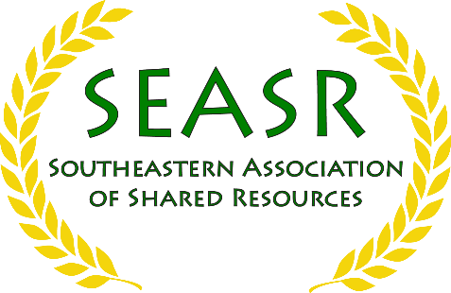
Sponsorship Form
2020 SEASR Conference
Emory Conference Center Hotel, June 10-12, 2020
http://seasr.abrf.org/

Sponsorship Level and Availability for each level (more details available on the prospectus):

Please Select | Sponsorship Levels Available | Amount | Number available
 | Corporate Platinum Plus (15-min spotlight) | $5,500 | 3
 | Corporate Platinum (Opening Reception) | $4,500 | 1
 | Corporate Platinum (Luncheon) | $4,500 | 1
 | Corporate Platinum (Poster Reception) | $4,500 | 1
 | Corporate Gold | $2,500 | 15
 | Corporate Silver | $1,500 | 10
 | Corporate Bronze | $500 | Unlimited
 | Institutional Gold | $2,000 | 5
 | Institutional Silver | $1,200 | 5
 | Institutional Bronze | $400 | Unlimited

Please Select | Additional Sponsorship Opportunities | Amount | Number Available
 | Additional vendor registration (max 4 registrations total) | $650 | Unlimited
 | Vendor registration with no sponsorship (attendee) | $750 | Unlimited
Contact Information:
Name:
Title:
Company or Institution:
Address:
City, State, Zip Code:
Email: |  | Phone:
Comments:
E‐mail completed form and logo to Pritha Bagchi (pritha.bagchi@emory.edu) and Lyra Griffiths (lmbooke@emory.edu).
Invoicing and tax forms will be delivered to you from FASEB (Amalia Paul; apaul@faseb.org).
Sponsors who expect to pay after Jan 1, 2020 will be invoiced by AMR.

