Text for the website: (all the information in one click on the title below)

Speed mentoring returns-Pre-register for this session now!
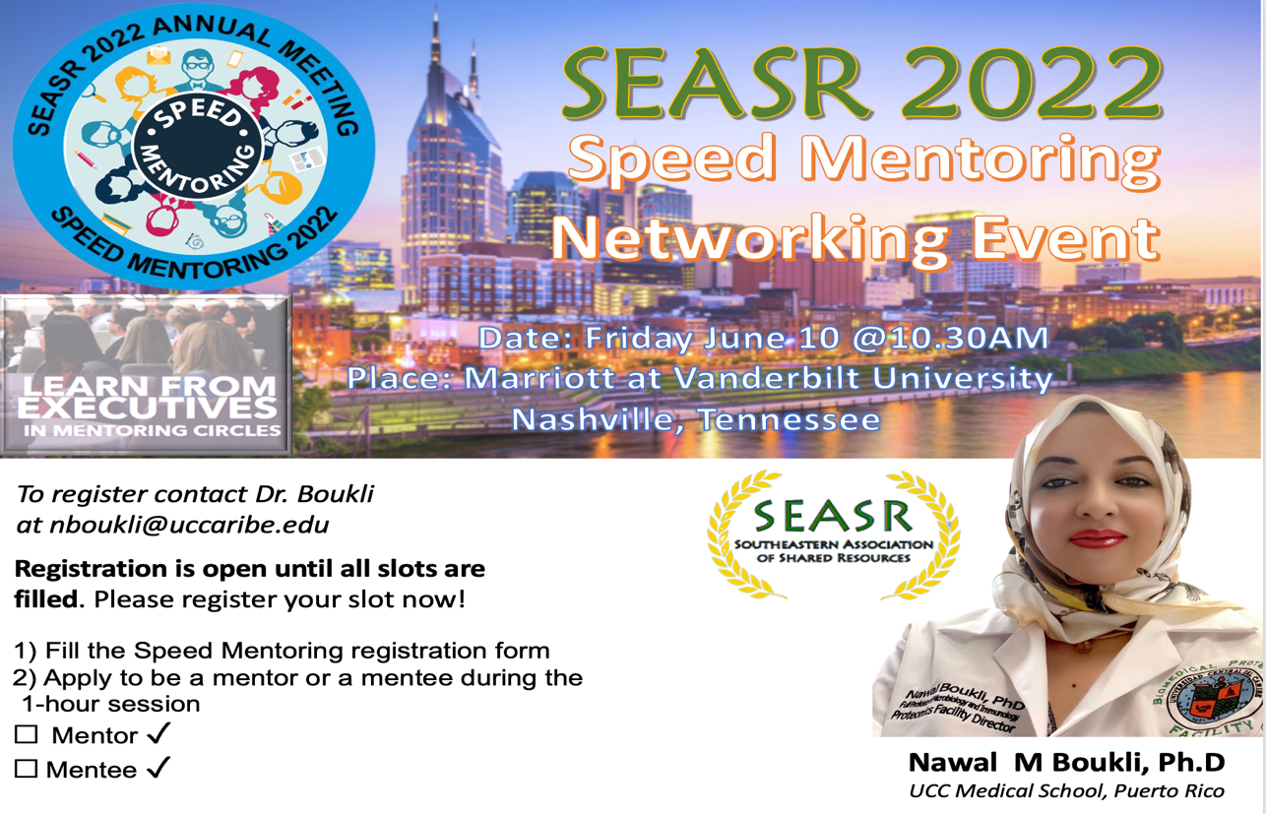
Dr. Boukli will lead a speed mentoring session on Friday, June 10th from 10:30 am-11:30 am (Crescent room)
Mentors will provide personalized one-to-one advice, guidance, and perspective on career advancement to mentees. Mentees will have the opportunity to listen to multiple mentors in a "speed-dating" format where mentees will spend about 5-10 minutes with a mentor, then rotate, to spend time with several mentors. This session will give participants the opportunity to personally connect with SEASR leaders and to continue networking after the meeting.

Pre-registration for either mentors or mentees is requested.
2022 SEASR Annual Conference Speed Mentoring event

Registration Form

Name:

Institution:

Job title: I will be attending the speed mentoring session as a (please check or highlight one):
☐Mentee ☐ Mentor
Please complete the registration form and return to Dr. Boukli.

